Sterile Compounding and Aseptic Technique for Pharmacists and Technicians:
A structured program designed to meet the requirements of the Texas State Board of Pharmacy for pharmacists and technicians who compound sterile products.or desire to learn and increase their knowledge of sterile compounding and aseptic technique.
Learning Objectives:
At the completion of this activity, the participant will be able to:
- Identify and define medical and pharmacy terminology and abbreviations used in sterile compounding.
- List and compare the various calculation methods that are appropriate for specific sterile compounding scenarios.
- Solve equations using the basic dosage calculation, ratio-proportion, and dimensional analysis in the preparation of CSPs.
- Apply pharmacy math and aseptic technique principals to CSP procedures.
- Describe and evaluate USP<797> principles related to sterile compounding and aseptic technique.
- Use appropriate pharmaceutical calculation methods in sterile compounding scenarios.
- Assemble various compounded sterile preparations.
- Demonstrate compliance with fundamental aseptic technique requirements during process validation procedures.

PROGRAM SCHEDULE
Students will complete approximately 24 hours of home study, including reading, and homework assignments, 16 hours (two days) of live instruction, practicum and process validation will be at Excel Career Training Center located at 2828 Forest lane, Suite 2121, Dallas, TX 75234

Accreditation Information
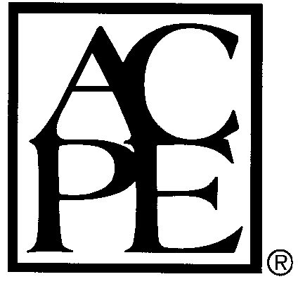
The Texas Society of Health-System Pharmacists (TSHP) is accredited by the Accreditation Council for Pharmacy Education as a provider of continuing pharmacy education. The Sterile Compounding for Aseptic Technique (SCAT) training course has been accredited for 40.0 hours (4.0 CEUs) of credit.

To receive credit the participant must provide the student registration information form, documentation of training hours form, and CPE evaluation form. The participant will be required to complete nine (9) process validations (w/100% compliance to SCAT principals), and two (2) written exams (with ≥ 75%). This practice-based activity is accredited as Universal Activity Number 0156-9999-16-094-B01-P & 0156-9999-16-094-B01-T. This activity will expire August 3, 2019. This activity is made possible through a co-sponsorship between TSHP and the Austin Community College Pharmacy Technician Program.

All credits will be issued through the My CPE Monitor website via participant's NABP e-Profile. Each participant is required to provide their NABP ePID and month and day of birth; CPE credits will not be issued to individuals that do not provide this information.
REFUND POLICY: NO REFUND but a 50% refund will be granted for written cancellation received by the deadline date.

R E G I S T R A T I O N F O R M

Sterile Compounding and Aseptic Technique for Pharmacists and Technicians
(UAN #0156-9999-16-094-B01-P & 0156-9999-16-094-B01-T) 4.0 CEU, 40.0 Contacts Hours)

Instructor: Eugenia Agugua, PharmD RPh
Registration Fee: $695

(PLEASE PRINT) ETHNIC GRP: GENDER:

Name________________________________DOB__________NABP e-Profile ID#___________ __RPh _Technician

Address____________________________________________ City___________________________ ST_______ ZIP__________

Pharmacy_______________________ Pharmacy/Tel.No._________________Email phone#_______________
Home study materials will be provided 10 days after receipt of registration and payment.
Make check payable to: Excel Career Training, Inc.
Send registration to: Excel Career Training, Inc. 2828 Forest Lane, Suite 2121, Dallas, TX 75234 Any questions? Please call 469.828.1981 or email us at excelcareertraining@yahoo.com
Cell 469.422.3874
For future schedules , visit our website at www.excelcareertraining.org

